**Mid Day Park**

***Work-flow to Use Mid Day Park***

Use **Add Preference** to obtain a baseline dialog that sets mid day park defaults



Repeat **Add Preference** for additional instances of the baseline dialog



Use **Load Template** for a more advanced preference setup



Repeat **Load Template** for additional instances of any template



***Preference Overview***

If a break is scheduled during the work day, it may be required to park the vehicle in a designated mid day park location, typically a depot.

***Add Preference Dialog***

**Purpose:**

The **Mid day park - default** dialog provides the minimum requirements to configure mid day parking.

**Prerequisites:** A mid day park location (depot) must be defined in the user data.

***Templates Available from Optibus***

***Mid Day Park***

**Purpose:**

This template allows a mid day park suject to two main conditions: A minimal park time that makes it worthwile



The park time must fit inside a minimal break length.



The second condition prevents the undesirable situation where a driver finishing his break, cannot take out the vehicle for an additional legth of time.

**Prerequisites:** A mid day park location (depot) defined in the user data may be required.

**Opening Dialog:**

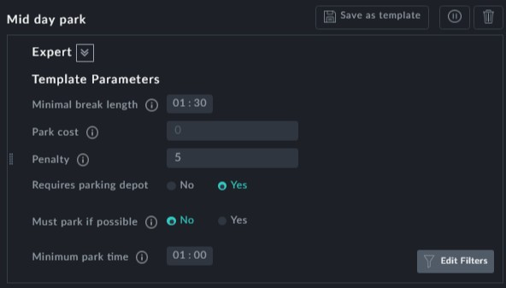

**Points to note:**

In the **Template Parameters** -

**Minimum break length**: This is the minimum break length during which a mid day park is allowed. If it is exceeded, the vehicle is always returned to a depot



**Requires parking depot**: Leave this as Yes. A parking depot must have been defined



in the user data and this is the default case. Do not set it to No.

**Must park if possible**: **Should enforce a mid day park if it's possible to do so (i.e. the break is greater than the minimum required break and there is enough time at the depot.** This should be set to Yes.



**Fixed cost for the mid day park**